1.DFA SIMULATOR:-

AIM:-

* To construct the DFA diagram by using simulator.

PROCEDURE:-

* Initially , install the autosimulator.
* open the autosim , click on the files.
* select the new and choose the DFA .
* Take two states .one is for initial state and another for final state.
* Connect the two states that accepts the conditions.
* click the run button and give the input.
* check the NFA diagram it will reach final state or not.
* it will reach final state means construction of our NFA diagram is correct.

DIAGRAM AND OUTPUT:-

INPUT=bcaaaaaaaaa,bc,c

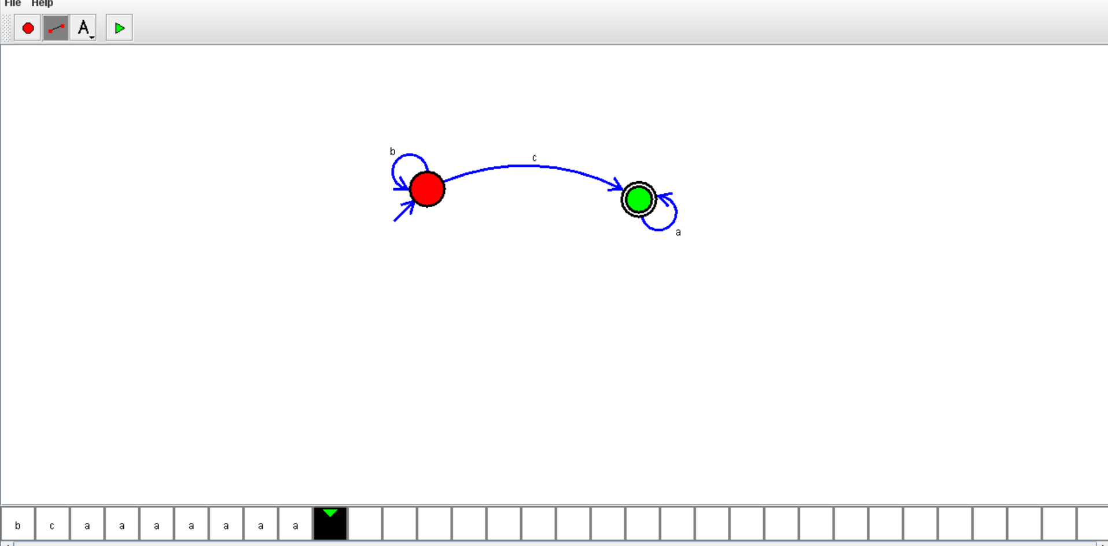

RESULT:-

* We got the output successfully . therefore the DFA diagram will accepts the conditions.

2.NFA SIMULATOR

AIM:-

To construct the NFA diagram by using simulator.

PROCEDURE:-

1.Initially,install the autosimulator.

2.open the autosim,click on the files.

3.select the new and choose the NFA .

4.Take two states .one is for initial state and another for final state.

5.Connect the two states that accepts the conditions.

6.click the run button and give the input.

7.check the NFA diagram it will reach final state or not.

8.it will reach final state means construction of our NFA diagram is correct.

DIAGRAM AND OUTPUT:-

INPUT:-aaaaaa

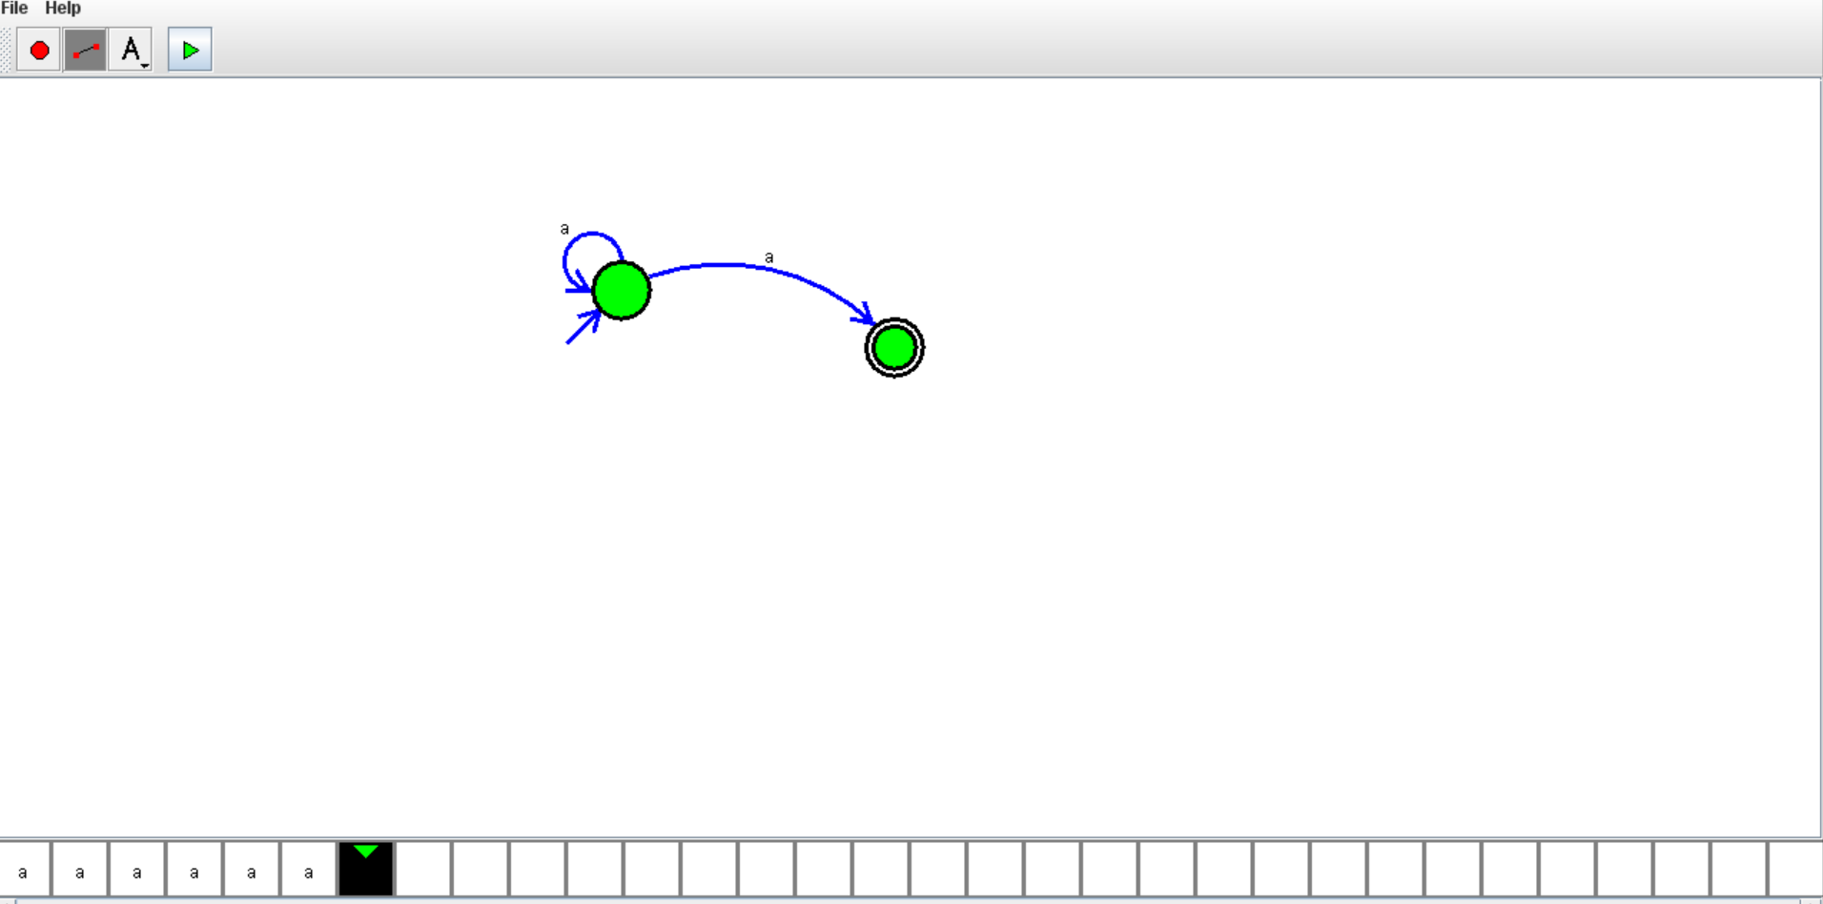

RESULT:-

* We got the output successfully . therefore the NFA diagram will accepts the conditions.

3.PDA STIMULATOR

AIM:-

* To construct the PDA diagram by using the simulator. And prove that the conditions have given.

PROCEDURE:-

1.Initially,install the autosimulator.

2.open the autosim , click on the files.

3.open new and select PDA diagram.

4.draw the PDA diagram with representing present state,next state and final state.

5.give the connections such that it accepts the input.

6.make sure that the given connections are satisfy the conditions.

7.click the run button and give the input.

8.check the PDA diagram it will reach final state or not.

9.it will reach final state means construction of our PDA diagram is correct.

DIAGRAM AND OUTPUT:-

INPUT=aabbc

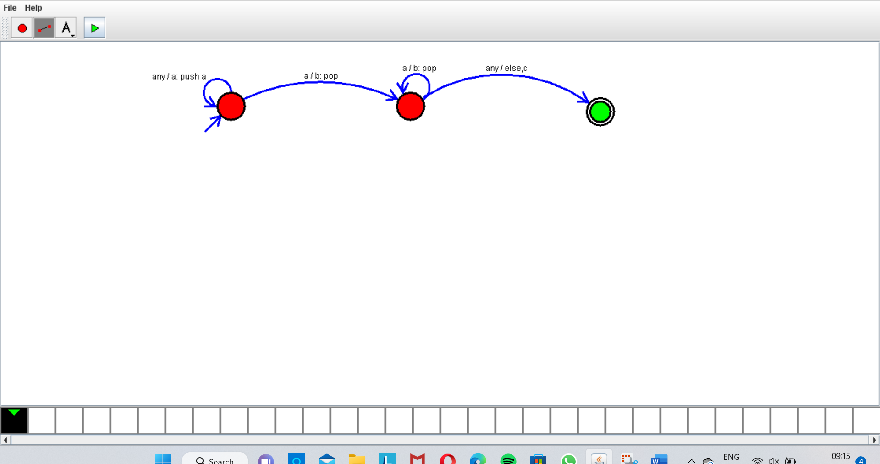

RESULT:-

* We got the output successfully . therefore the PDA diagram will accepts the conditions.

4.TURING MACHINE

AIM:-

* To construct the Turing Machine diagram by using the simulator. And prove that the conditions have given.

PROCEDURE:-

* Initially,install the autosimulator.
* open the autosim , click on the files.
* open new and select Turing Machine diagram.
* draw the Turing Machine diagram with representing present state,next state and final state.
* give the connections such that it accepts the input.
* make sure that the given connections are satisfy the conditions.
* give the input and click on the run button.
* Check the Turing Machine diagram it will reach final state or not.
* it will reach final state means construction of our Turing Machine diagram is correct.

DIAGRAM AND OUTPUT:-

INPUT=aabb

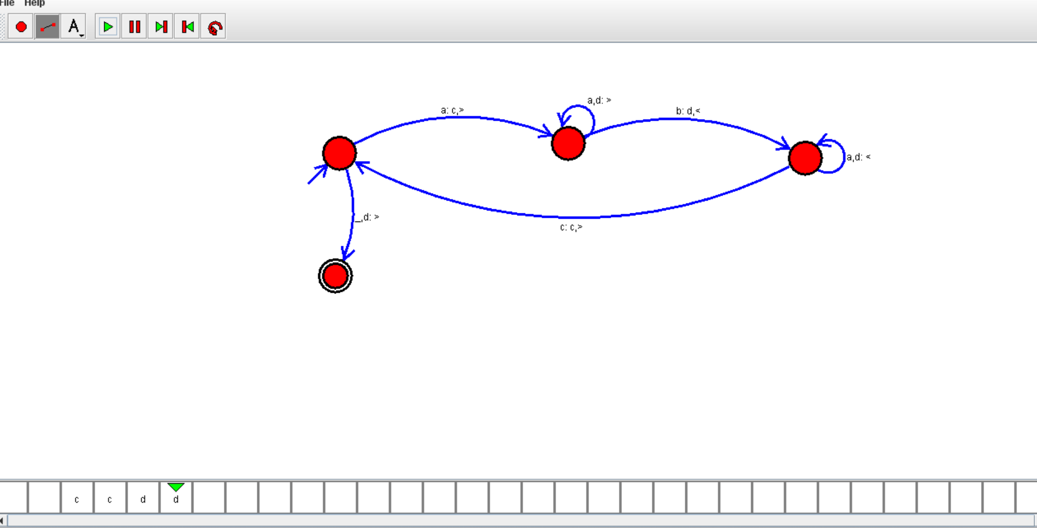

RESULTS:-

We got the output successfully . therefore the Turing Machine diagram will accepts the conditions.

5.PDA STIMULATOR

AIM:-

* To construct the PDA diagram by using the simulator. And prove that the conditions have given.

PROCEDURE:-

1.Initially,install the autosimulator.

2.open the autosim , click on the files.

3.open new and select PDA diagram.

4.draw the PDA diagram with representing present state,next state and final state.

5.give the connections such that it accepts the input.

6.make sure that the given connections are satisfy the conditions.

7.click the run button and give the input.

8.check the PDA diagram it will reach final state or not.

9.it will reach final state means construction of our PDA diagram is correct.

DIAGRAM AND OUTPUT:-

INPUT=aabbc

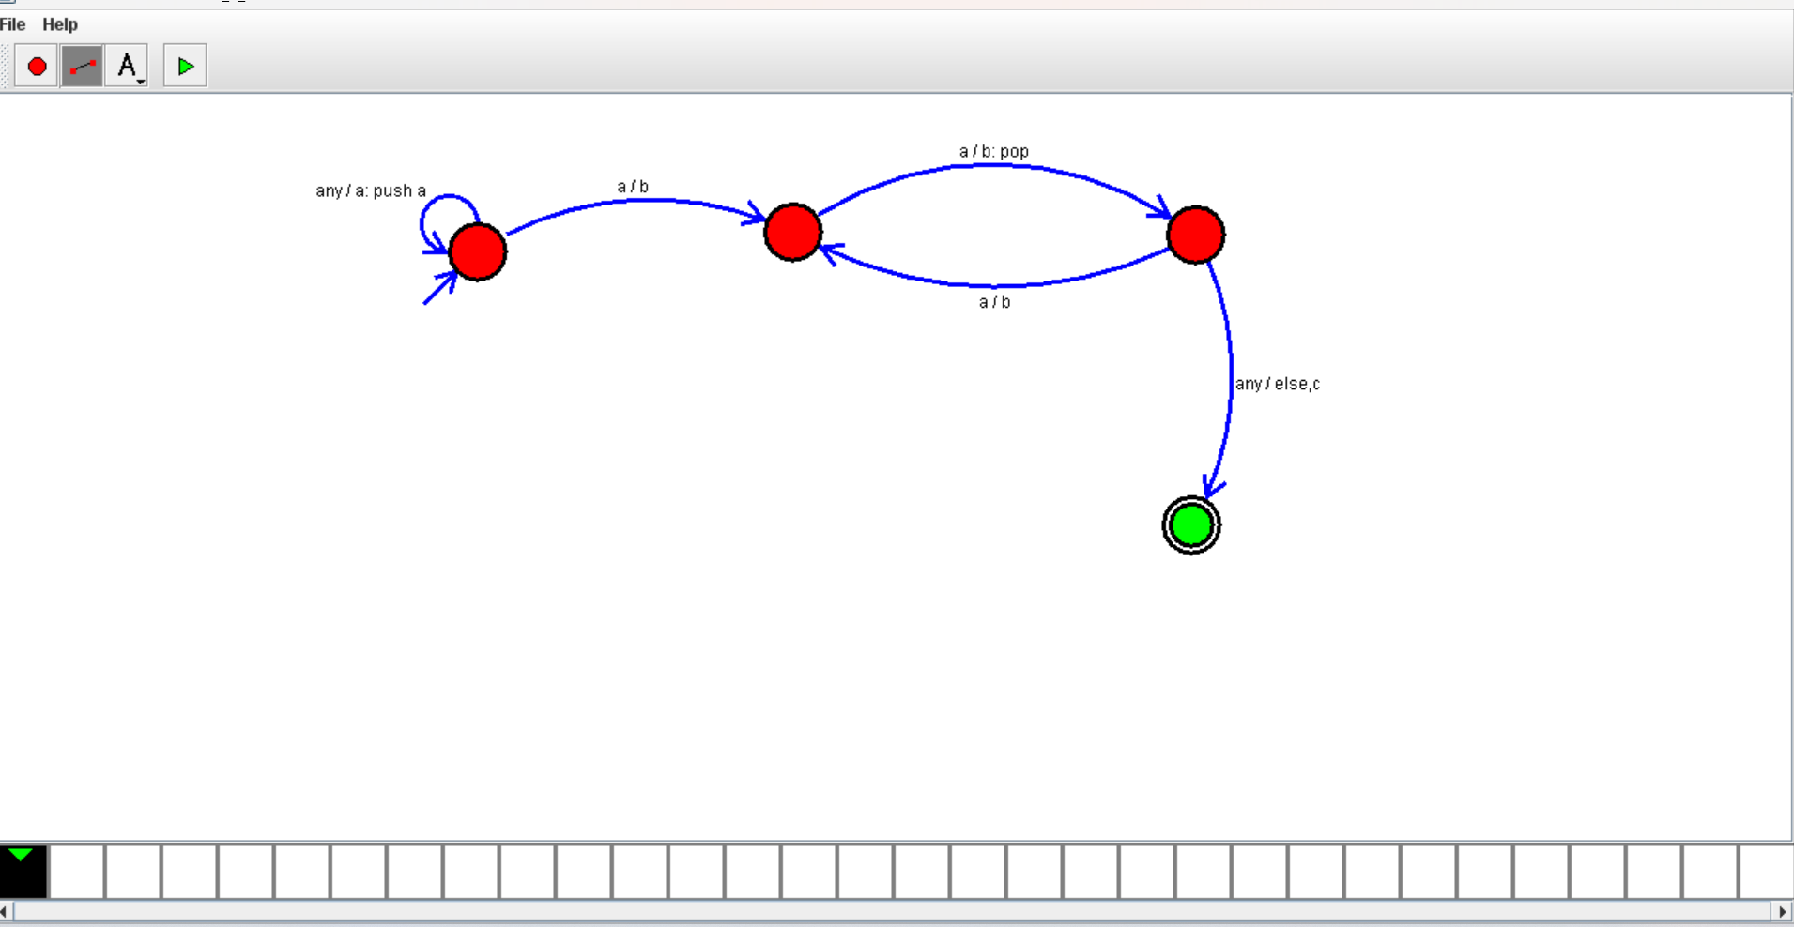

RESULT:-

* We got the output successfully . therefore the PDA diagram will accepts the conditions.

6.TURING MACHINE STIMULATION-PALINDROME

AIM:-

* To construct the Turing Machine diagram by using the simulator. And prove that the conditions have given.

PROCEDURE:-

* Initially,install the autosimulator.
* open the autosim , click on the files.
* open new and select Turing Machine diagram.
* draw the Turing Machine diagram with representing present state,next state and final state.
* give the connections such that it accepts the input.
* make sure that the given connections are satisfy the conditions.
* give the input and click on the run button.
* Check the Turing Machine diagram it will reach final state or not.
* it will reach final state means construction of our Turing Machine diagram is correct.

DIAGRAM AND OUTPUT:-

INPUT =ababa c

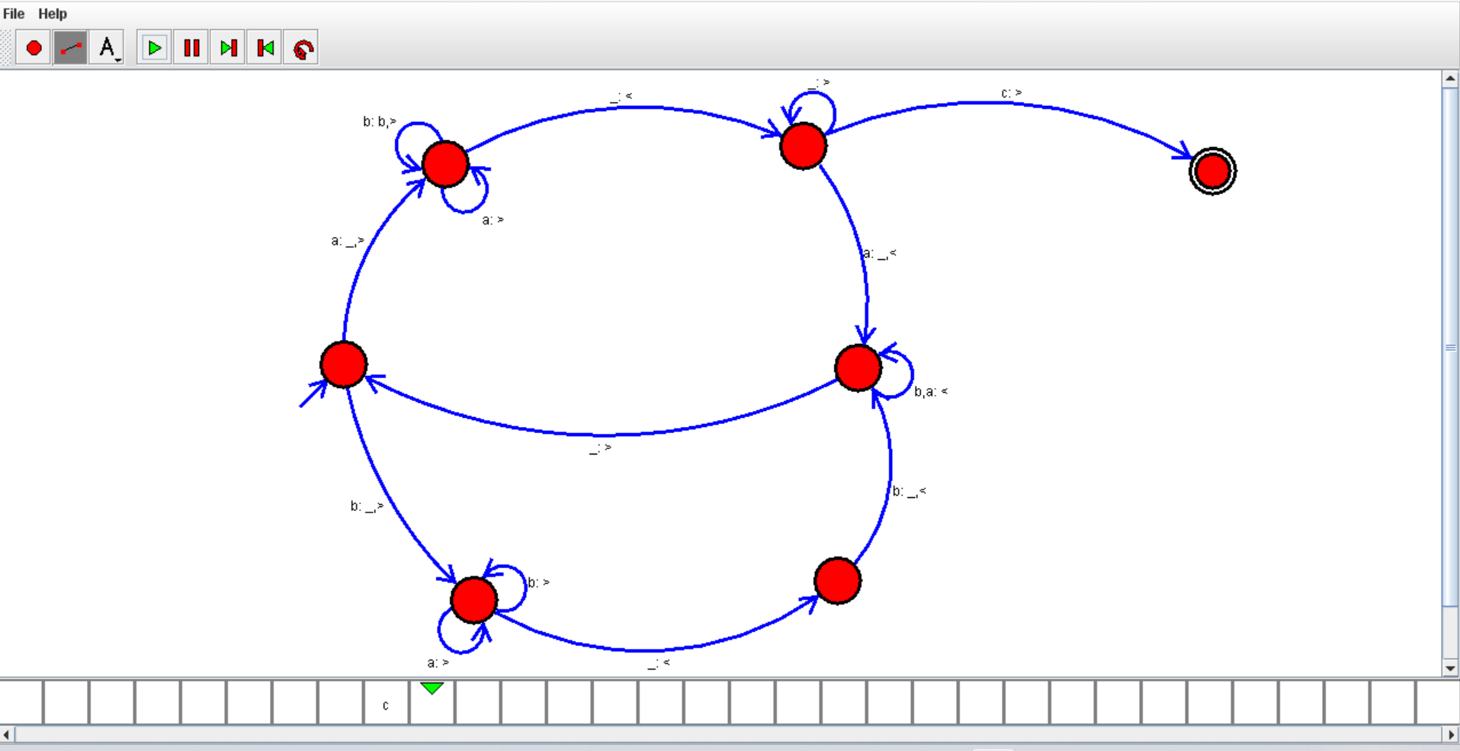

RESULTS:-

* We got the output successfully . therefore the Turing Machine diagram will accepts the conditions.

7.TURING MACHINE-ADDITION

AIM:-

* To construct the Turing Machine diagram by using the simulator. And prove that the conditions have given.

PROCEDURE:-

* Initially,install the autosimulator.
* open the autosim , click on the files.
* open new and select Turing Machine diagram.
* draw the Turing Machine diagram with representing present state,next state and final state.
* give the connections such that it accepts the input.
* make sure that the given connections are satisfy the conditions.
* give the input and click on the run button.
* Check the Turing Machine diagram it will reach final state or not.
* it will reach final state means construction of our Turing Machine diagram is correct.

DIAGRAM AND OUTPUT:-

INPUT=aadaaaa

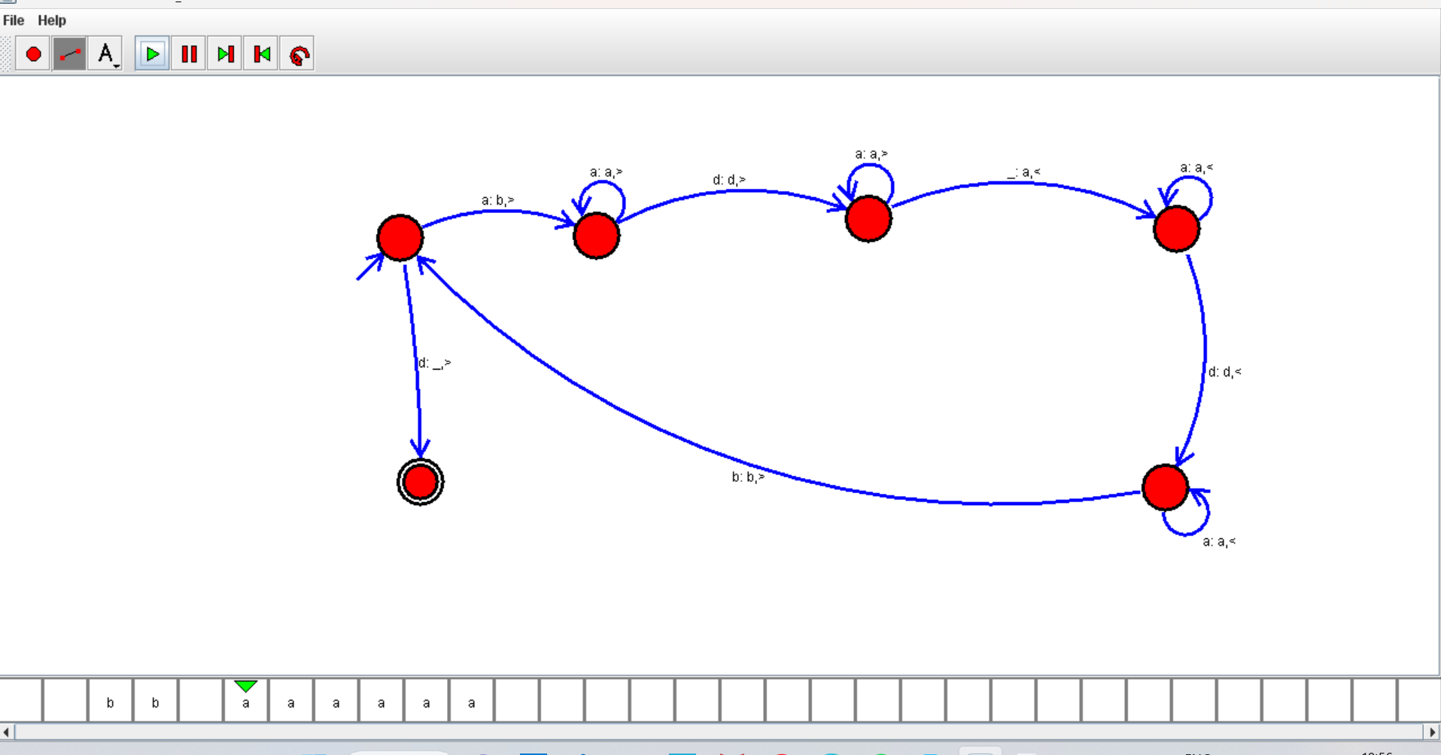

RESULTS:-

* We got the output successfully . therefore the Turing Machine diagram will accepts the conditions.

8.TURING MACHINE – SUBTRACTION

AIM:-

* To construct the Turing Machine diagram by using the simulator. And prove that the conditions have given.

PROCEDURE:-

* Initially,install the autosimulator.
* open the autosim , click on the files.
* open new and select Turing Machine diagram.
* draw the Turing Machine diagram with representing present state,next state and final state.
* give the connections such that it accepts the input.
* make sure that the given connections are satisfy the conditions.
* give the input and click on the run button.
* Check the Turing Machine diagram it will reach final state or not.
* it will reach final state means construction of our Turing Machine diagram is correct.

DIAGRAM AND OUTPUT:-

INPUT=aaa aa

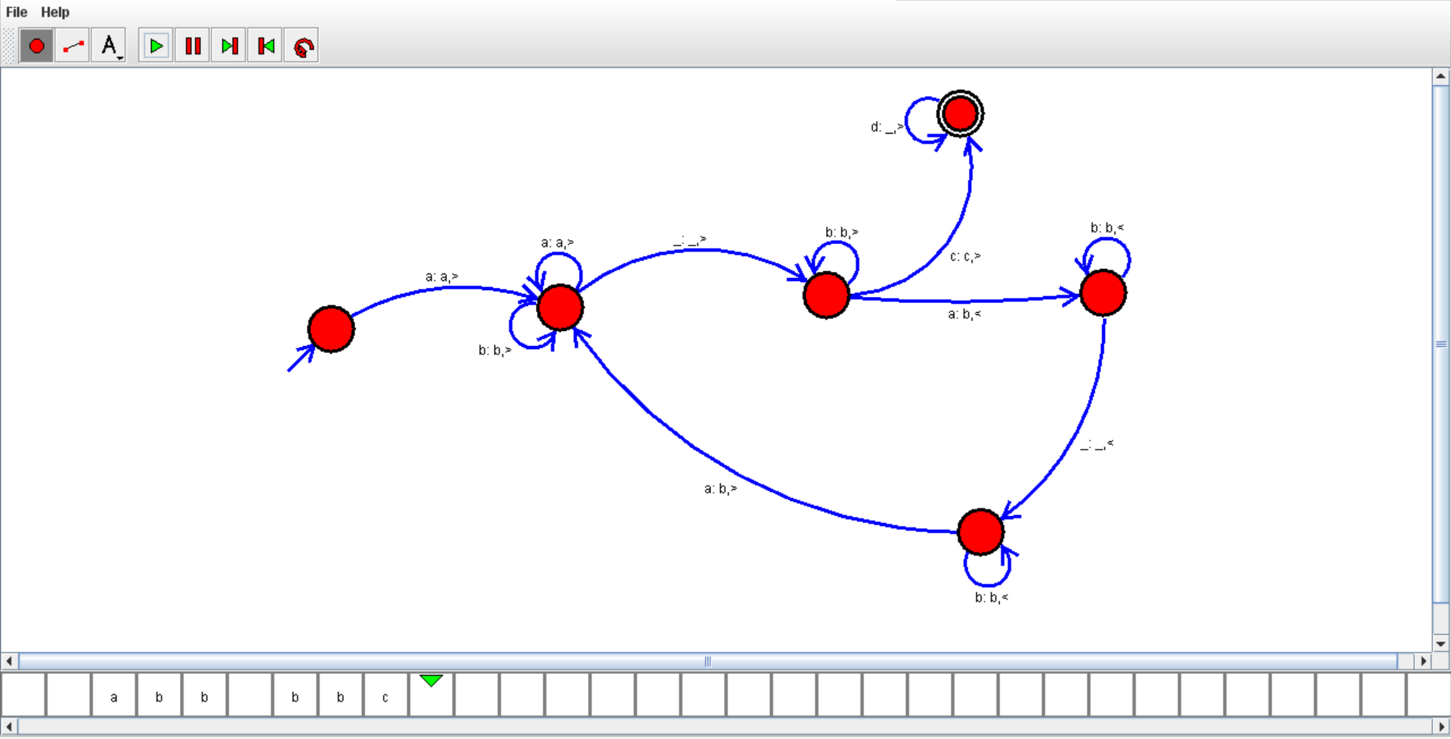

RESULTS:-

* We got the output successfully . therefore the Turing Machine diagram will accepts the conditions.

9.TURING MACHINE – STRING

AIM:-

* To construct the Turing Machine diagram by using the simulator. And prove that the conditions have given.

PROCEDURE:-

* Initially,install the autosimulator.
* open the autosim , click on the files.
* open new and select Turing Machine diagram.
* draw the Turing Machine diagram with representing present state,next state and final state.
* give the connections such that it accepts the input.
* make sure that the given connections are satisfy the conditions.
* give the input and click on the run button.
* Check the Turing Machine diagram it will reach final state or not.
* it will reach final state means construction of our Turing Machine diagram is correct.

DIAGRAM AND OUTPUT:-

INPUT=aba aba

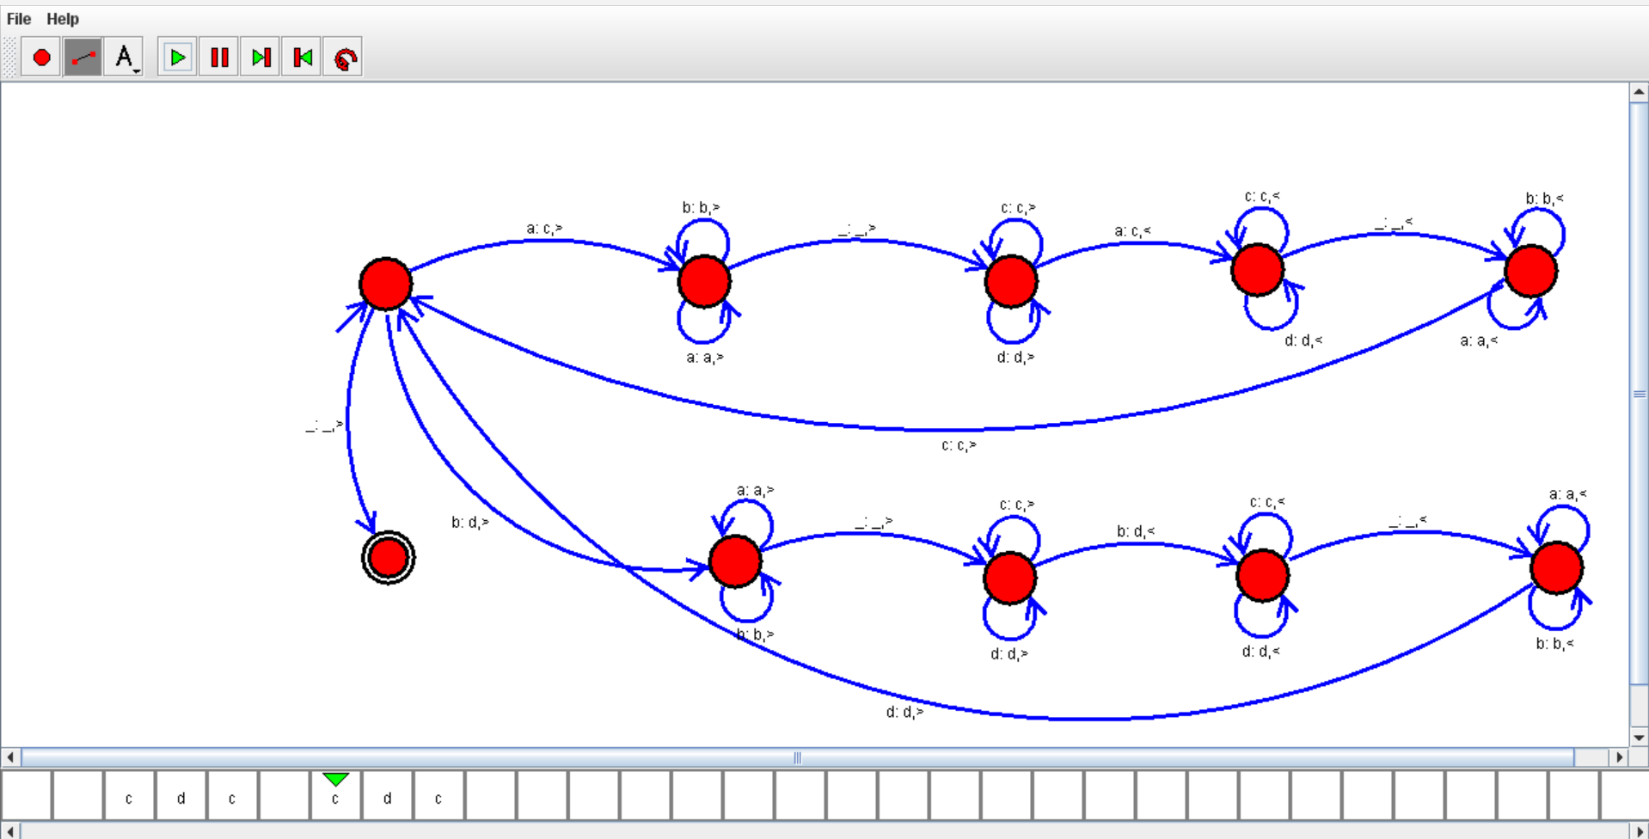

RESULTS:-

* We got the output successfully . therefore the Turing Machine diagram will accepts the conditions.

10.DFA-EVEN A

AIM:-

* To construct the DFA diagram by using simulator.

PROCEDURE:-

* Initially , install the autosimulator.
* open the autosim , click on the files.
* select the new and choose the DFA .
* Take two states .one is for initial state and another for final state.
* Connect the two states that accepts the conditions.
* click the run button and give the input.
* check the NFA diagram it will reach final state or not.
* it will reach final state means construction of our NFA diagram is correct.

DIAGRAM AND OUTPUT:-

INPUT=A

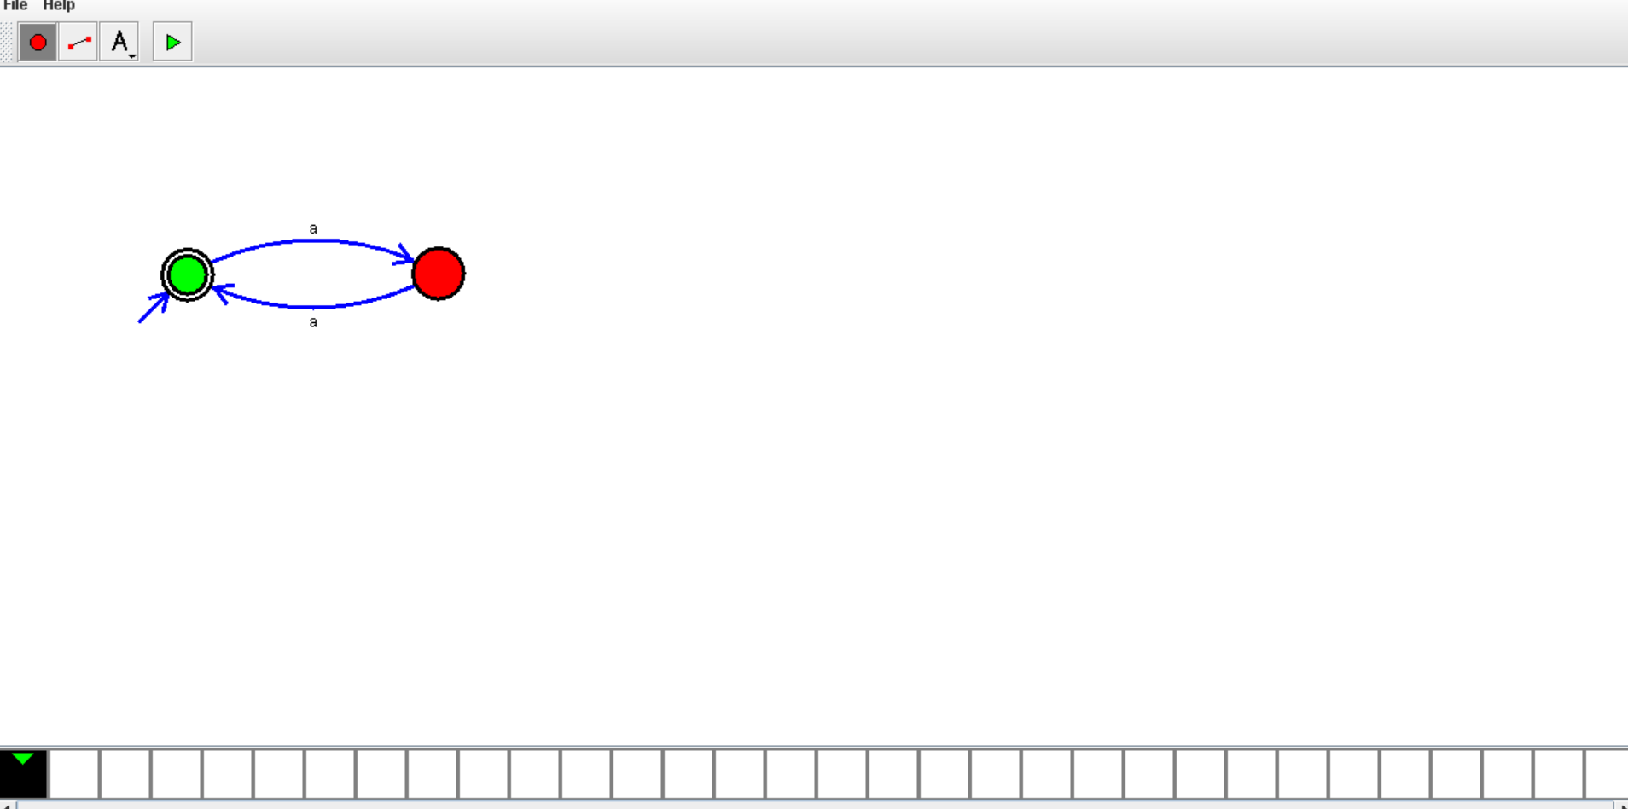

RESULTS:-

* We got the output successfully . therefore the DFA diagram will accepts the conditions.

11.DFA-ODD-A

AIM:-

* To construct the DFA diagram by using simulator.

PROCEDURE:-

* Initially , install the autosimulator.
* open the autosim , click on the files.
* select the new and choose the DFA .
* Take two states .one is for initial state and another for final state.
* Connect the two states that accepts the conditions.
* click the run button and give the input.
* check the NFA diagram it will reach final state or not.
* it will reach final state means construction of our NFA diagram is correct.

DIAGRAM AND OUTPUT:-

INPUT=A

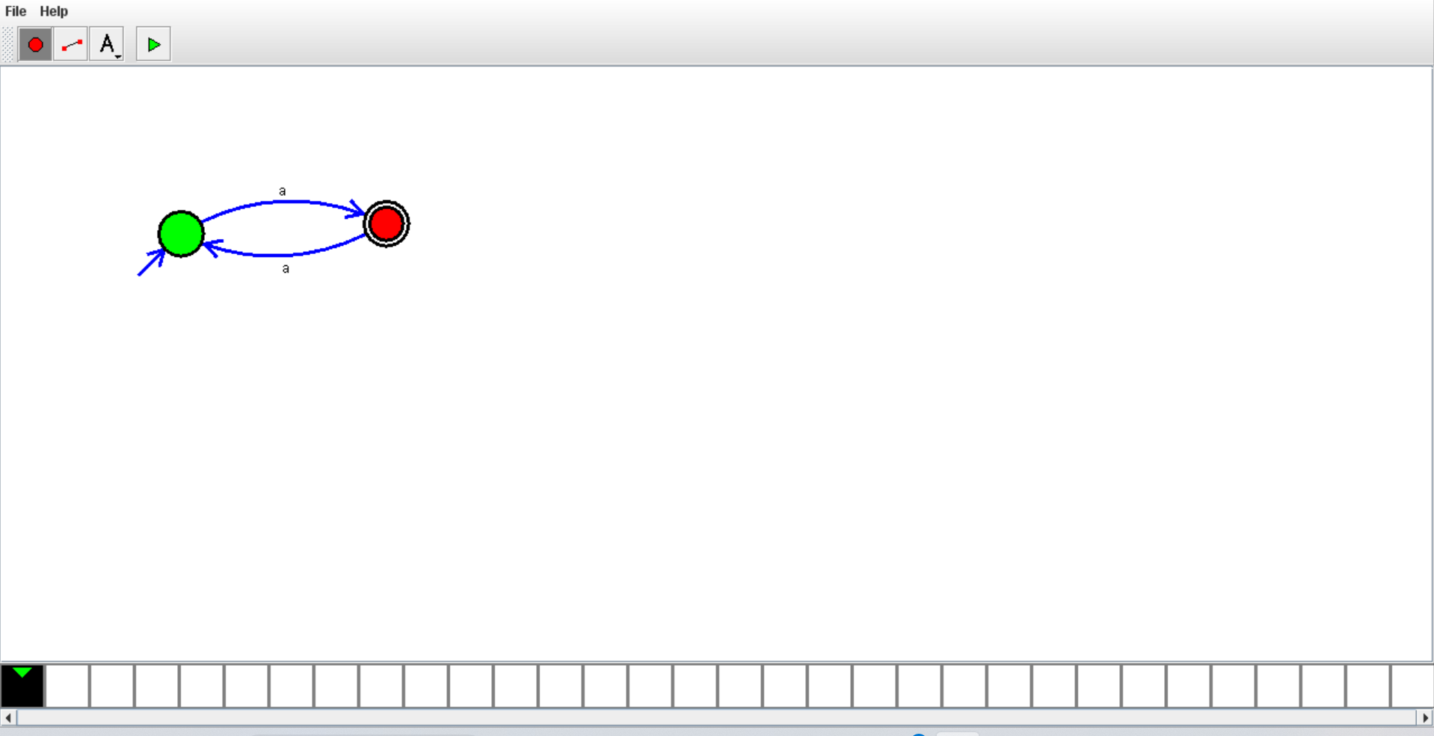

RESULTS:-

* We got the output successfully . therefore the DFA diagram will accepts the conditions.

12.DFA SUBSTRING ab

AIM:-

* To construct the DFA diagram by using simulator.

PROCEDURE:-

* Initially , install the autosimulator.
* open the autosim , click on the files.
* select the new and choose the DFA .
* Take two states .one is for initial state and another for final state.
* Connect the two states that accepts the conditions.
* click the run button and give the input.
* check the NFA diagram it will reach final state or not.
* it will reach final state means construction of our NFA diagram is correct.

DIAGRAM AND OUTPUT:-

INPUT=ab

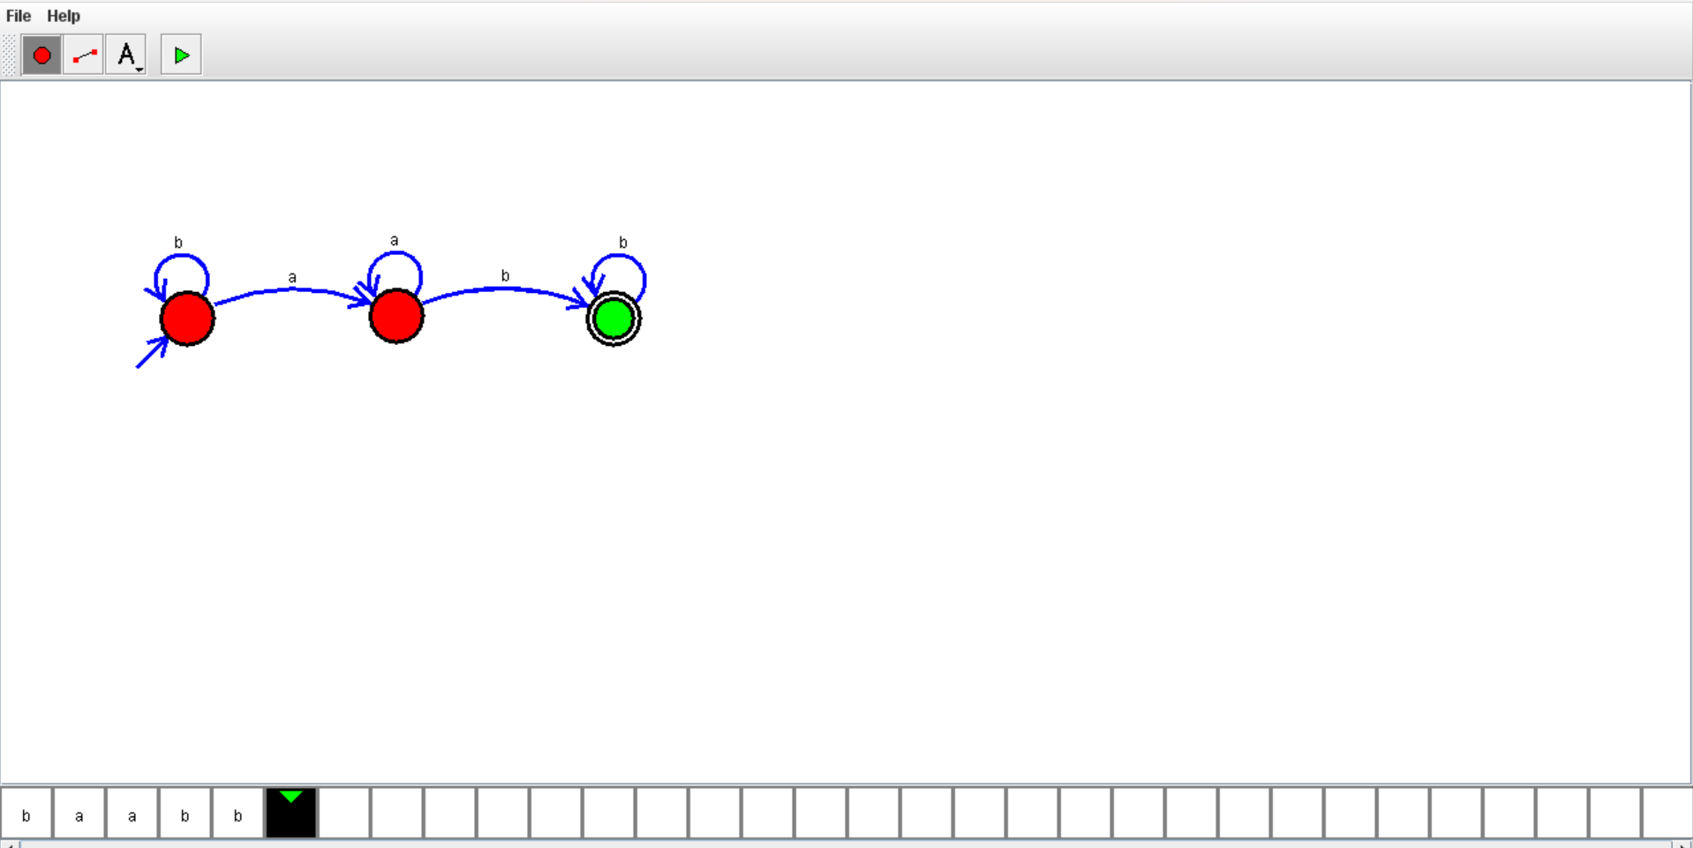

RESULTS:-

* We got the output successfully . therefore the DFA diagram will accepts the conditions.

13.DFA START WITH A OR B

AIM:-

* To construct the DFA diagram by using simulator.

PROCEDURE:-

* Initially , install the autosimulator.
* open the autosim , click on the files.
* select the new and choose the DFA .
* Take two states .one is for initial state and another for final state.
* Connect the two states that accepts the conditions.
* click the run button and give the input.
* check the NFA diagram it will reach final state or not.
* it will reach final state means construction of our NFA diagram is correct.

DIAGRAM AND OUTPUT:-

INPUT=aa

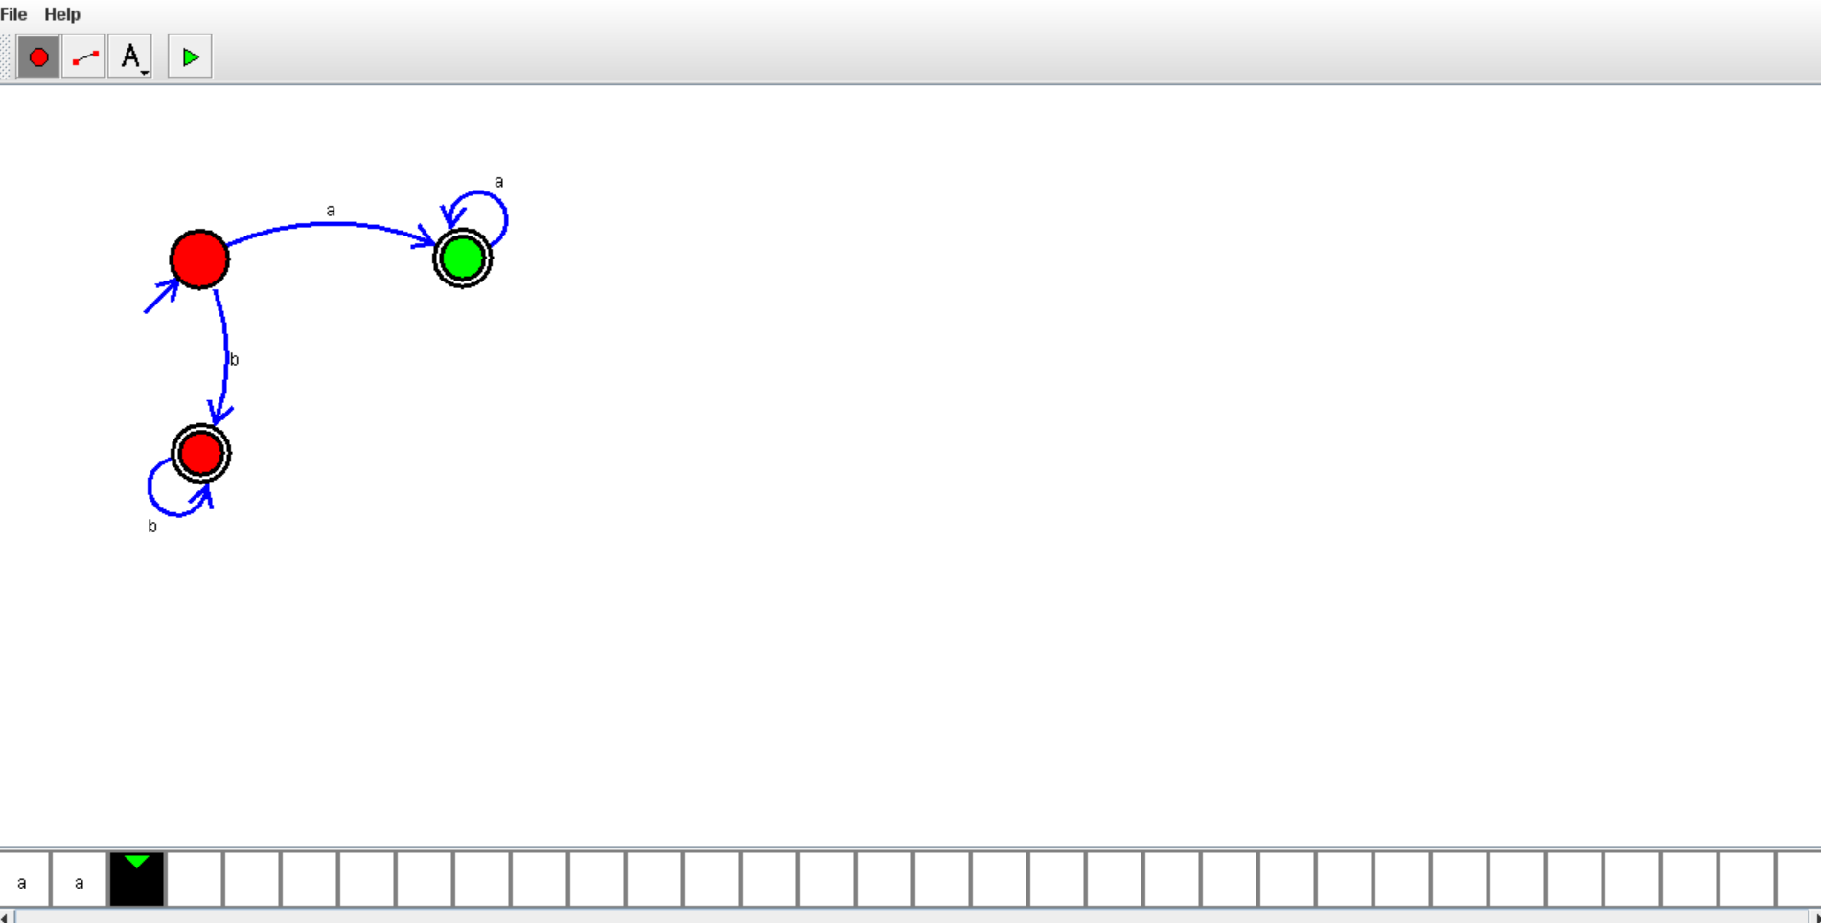

RESULTS:-

* We got the output successfully . therefore the DFA diagram will accepts the conditions.